Name of Student: Aman Srivastava

Reg. No.: 20BCE10873

Slot: Internet and web programming

**Assignment-2: Css: Inline, Internal and External**

**WAY-1: inline Css**

<!DOCTYPE html>

<html lang="en">

  <head>

    <meta charset="UTF-8" />

    <meta http-equiv="X-UA-Compatible" content="IE=edge" />

    <meta name="viewport" content="width=device-width, initial-scale=1.0" />

    <title>Css</title>

    /*ADD STYLE SHEET: WAY1 INLINE CSS*/

    <style>

      #First {

        background-color: aqua;

      }

      .bg-blue {

        background-color: blue;

        color: azure;

      }

    </style>

  </head>

  <body>

    <div id="First">First</div>

    <div id="Second">Second</div>

    <section class="red">Red</section>

    <section class="red bg-blue border-purple">

      Red bg-blue and border-purple

    </section>

  </body>

</html>

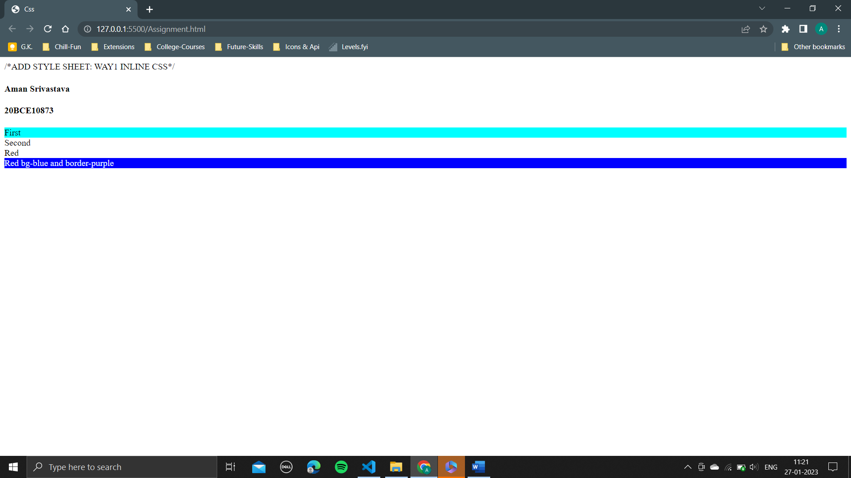

**WAY-2: Internal Css**

<!DOCTYPE html>

<html lang="en">

  <head>

    <meta charset="UTF-8" />

    <meta http-equiv="X-UA-Compatible" content="IE=edge" />

    <meta name="viewport" content="width=device-width, initial-scale=1.0" />

    <title>Css</title>

    /*ADD STYLE SHEET: WAY1 Internal CSS*/

  </head>

  <body>

    <h4>Aman Srivastava</h4>

    <h4>20BCE10873</h4>

    <div id="First" style="background-color: blue">First</div>

    <div id="Second">Second</div>

    <section class="red">Red</section>

    <section class="red bg-blue border-purple">

      Red bg-blue and border-purple

    </section>

  </body>

</html>

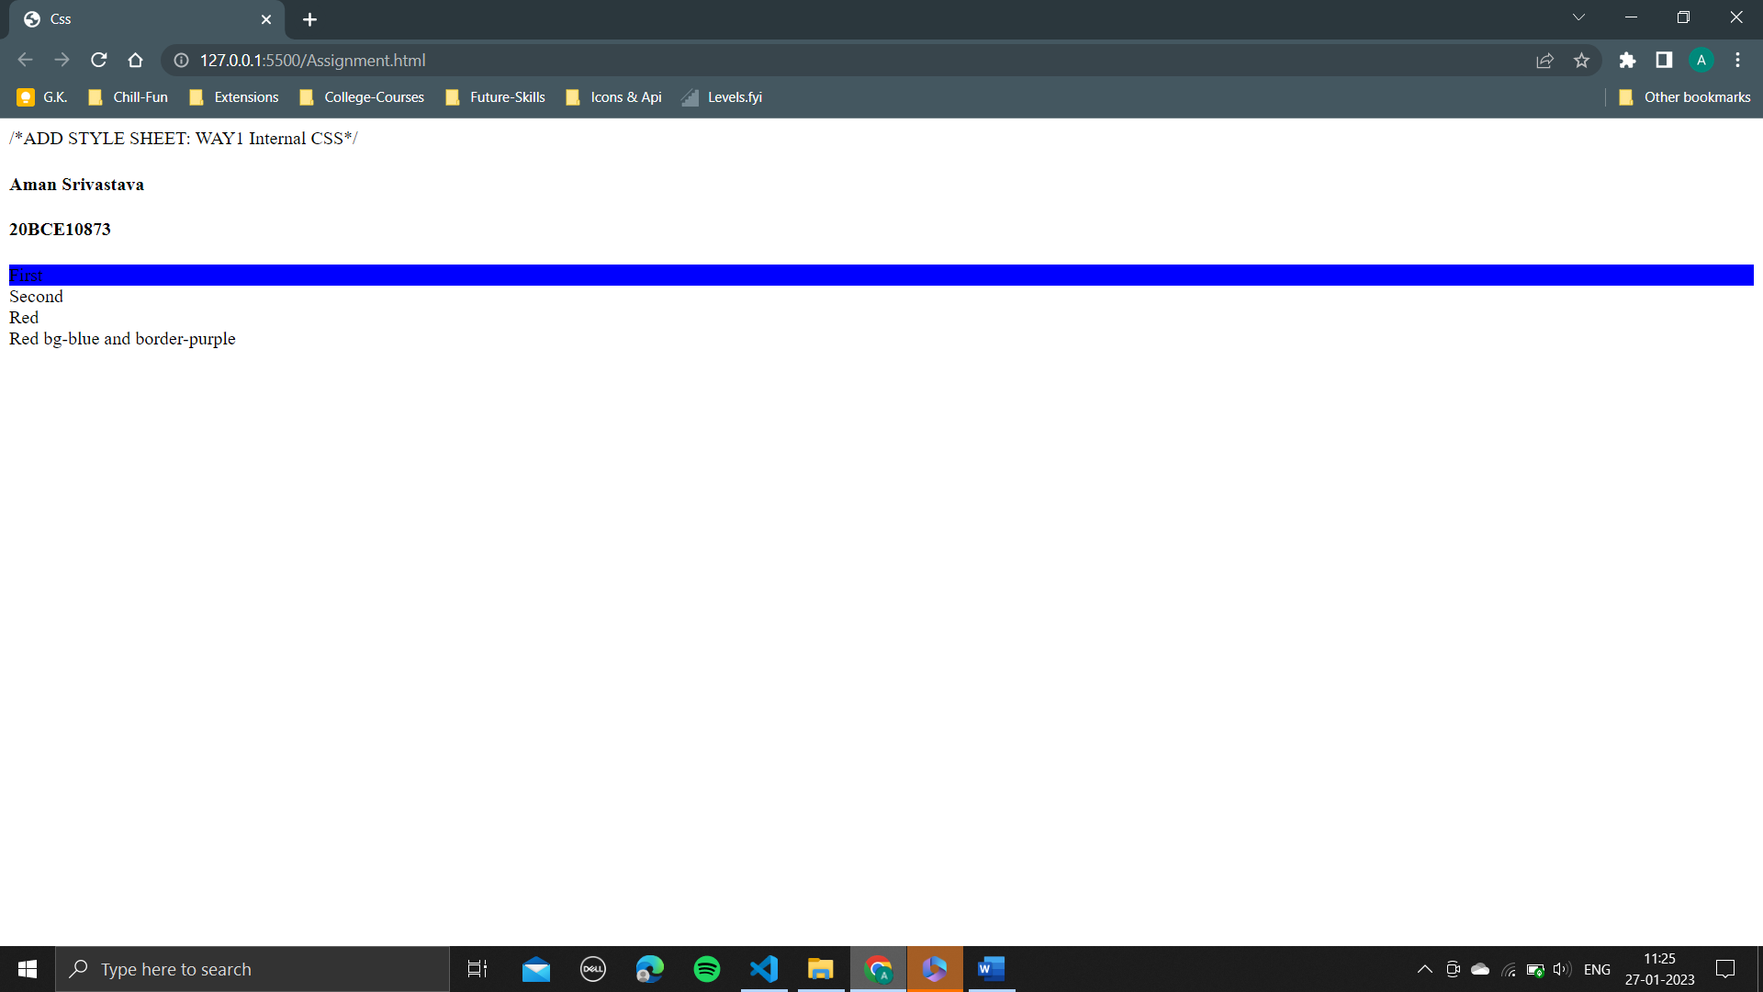

**WAY-3: External Css**

